78GIIN – Writing Skills for Engineering
Product Description Sheet
Gagliardo Miguel Angel
24 de Enero de 2025

1. Product Overview
The NVIDIA Jetson Nano is a compact, high-performance single-board computer designed for developers, students, and hobbyists working on artificial intelligence (AI) and machine learning (ML) projects. It brings powerful GPU-accelerated computing to small-scale applications, enabling a wide range of projects in robotics, smart cities, drones, and the Internet of Things (IoT).
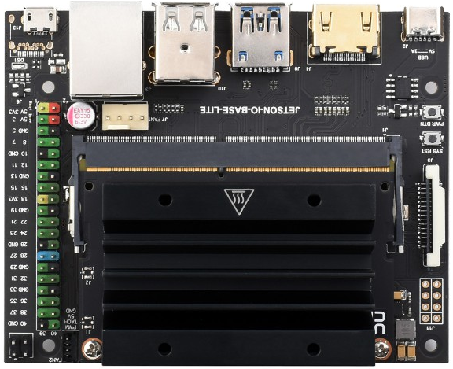

This small yet powerful device is engineered to run complex machine learning models and handle real-time processing, all while maintaining low power consumption. It’s ideal for anyone looking to create intelligent, interactive systems—whether you're a developer, student, or hobbyist. With its ability to accelerate AI applications, the Jetson Nano makes advanced computing accessible to a wider range of creators, offering flexibility for a variety of applications, from autonomous machines to smart home solutions.
The Jetson Nano allows users to take advantage of the latest advancements in AI and robotics, making cutting-edge technology more accessible and practical for real-world use, even in limited or remote environments.

2. Specifications
- AI and deep learning model acceleration via embedded GPU capabilities
- Robust I/O for peripheral connections
- Open-source software ecosystem for maximum flexibility
- Power-efficient design for embedded systems and portable applications
- USB and camera interface support for robotics and visual recognition applications

3. Features

Core Features

1. CPU and GPU Performance
- Quad-core ARM Cortex-A57 CPU and a 128-core Maxwell GPU for handling demanding AI, computer vision, and robotics tasks with ease.

2. Memory
- 4GB LPDDR4 RAM, providing ample space for complex models, multitasking, and smooth operation across different applications.

3. Storage
- microSD slot supporting up to 256GB, offering plenty of room for data storage, operating systems, and applications.

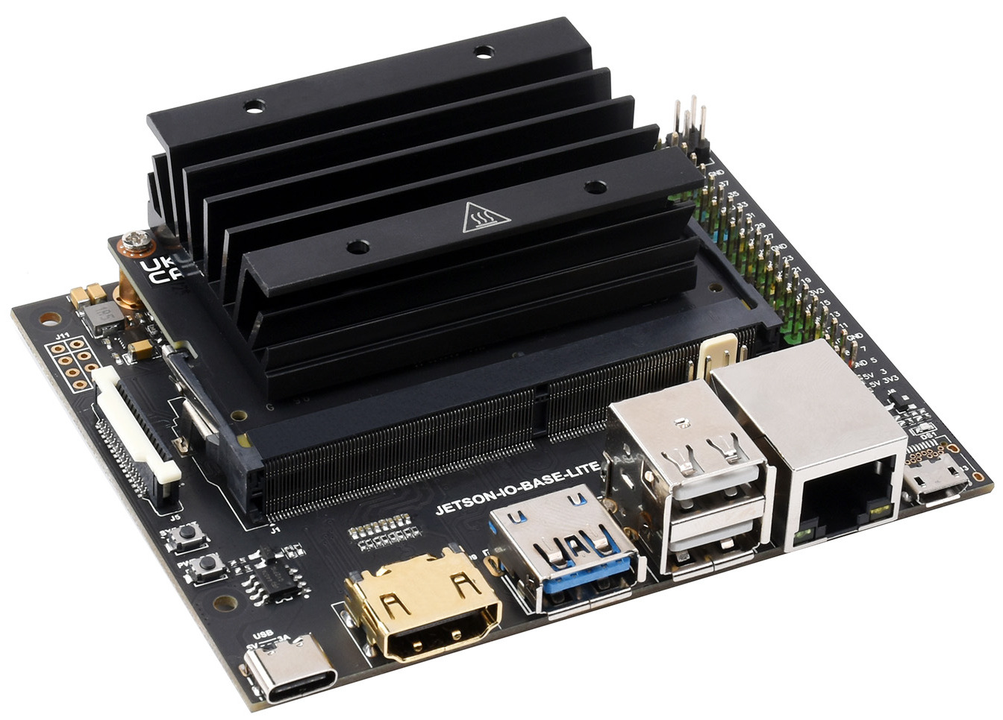
4. Connectivity

Gigabit Ethernet for reliable network connectivity.

USB 3.0 and 2.0 ports for connecting peripherals such as cameras, sensors, and other devices.

Wi-Fi and Bluetooth support via external adapters for flexible wireless connectivity.

5. Video and Display Output

- HDMI 2.0 port and DisplayPort 1.2 for easy connection to displays, monitors, or projectors.
- CSI camera connectors for integrating cameras to enable machine vision, object detection, and other AI-powered tasks.

6. I/O Pins
- 40-pin GPIO header supporting a wide variety of peripherals including motors, sensors, and actuators, making it perfect for robotics and IoT projects.

7. Software Ecosystem

- Preloaded with JetPack SDK that includes essential libraries and tools for AI development, including support for TensorFlow, PyTorch, OpenCV, and more.

8. Additional capabilities
- Wi-Fi and Bluetooth capabilities via add-ons
- Advanced storage options (e.g. SSD, NFS support)
- AI performance optimizations and software updates to support the latest algorithms
- Built-in power management for edge computing (battery-powered options)
- Enhanced multi-camera support for vision-based AI applications

4. Supported Systems and Environments
The Jetson Nano is designed to work in various environments and supports multiple systems. Below are key details on its compatibility.

Operating System
- Ubuntu-based Linux OS (Linux for Tegra): A stable and familiar environment for most developers, compatible with a wide range of software and tools.
- Supports JetPack SDK, which includes drivers, libraries, and APIs for AI, computer vision, and multimedia tasks.

Software Frameworks
- AI and Deep Learning: TensorFlow, PyTorch, Caffe, Keras, MXNet, and more
- Computer Vision: OpenCV and other computer vision libraries
- Robotics: ROS (Robot Operating System) support
- Embedded and IoT: Full support for Python, C++, and other programming languages used in embedded systems

Development Environments
- The Jetson Nano Developer Kit comes pre-loaded with essential tools and SDKs
- Can be programmed using Python, C++, or any other language supported by the Linux OS
- Supports integration with cloud services for data-intensive tasks when required, including AWS, Google Cloud, and Microsoft Azure

Supported Devices and Accessories
- Cameras: Compatible with various MIPI-CSI cameras
- Displays: Supports HDMI and DisplayPort monitors
- Peripherals: Works with a wide range of USB devices, such as keyboards, mice, and storage drives
- Robotics Hardware: Compatible with various sensor boards, motor drivers, and other robotics peripherals via GPIO, I2C, SPI, and UART

Use Cases
- Robotics: Ideal for autonomous vehicles, drones, and robotic systems that require edge AI for decision-making and navigation.
- Smart Cities: Used for traffic monitoring, surveillance, environmental monitoring, and other IoT-driven applications.
- AI Education: A perfect platform for students and educators to learn about machine learning, AI, and robotics with real-world applications.
- Edge Computing: Deployed in distributed computing systems where immediate data processing is essential, such as security cameras, medical devices, and industrial sensors.

5. Product Dimensions and Physical Design

Compact and Efficient Design
The Jetson Nano is small enough to be used in tight spaces yet powerful enough to handle demanding applications. Its compact design makes it suitable for various embedded systems and edge AI devices.
- Dimensions: 100mm x 80mm (approximately the size of a credit card)
- Weight: ~100 grams (without accessories)
- Power Supply: 5V 4A via Micro-USB or 5V/4A barrel jack
- Cooling: Passive heatsinks or active cooling (fan) can be added to prevent overheating in high-performance tasks

Portability and Deployment
With its small footprint, the Jetson Nano is highly portable and can be deployed in various environments, from lab setups to remote installations in the field.
